Aim of the Exercise

The purpose of the exercise is to understand the concept of ambiguity resolution, invertible ambiguity transformations and linear combination for the GNSS PPP measurements. The ambiguity resolution method is available for float solutions and with the help of adjustment approach. Ambiguities is in very small value in integers which affected by the hardware of the receiver. As per the receiver quality like low cost receiver has very less accuracy in ambiguity solutions while Javad has much more precise measurements. For achieving better precision and accuracy we are finding the integers value for an ambiguity. We can separate the ambiguities from instrumental errors by the Double Difference Approach.

Task 1

Task 1.1 Name the general steps (three) for ambiguity resolution and justify their need.

Why is a fixed solution more accurate than a float solution.

The 3 general steps for ambiguity resolutions are as :-

1- Ambiguities[n] are estimated as real-valued numbers together with all further parameters[x].

Float Solutions

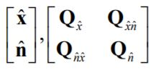

2- Determination of integers ambiguities and their validations   
 

3 – Final Estimations of all further parameters by introducing the integer ambiguities as fixed numbers.   
Fixed solutions

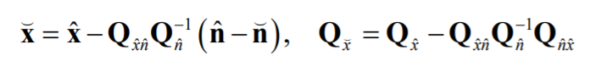

We are using Ambiguities Resolutions to find out the integers value for ambiguities to gain better precision and accuracy.

Step2

Fast Ambiguity Resolution Approach(FARA) method used in the 2nd step for ambiguity resolutions. The ambiguity which we got is real value and we want to search the integers value from it.

We are setting up the search space/feasible region to optimizations. Firstly find out the possible candidates so all the integers entries in our respected search space are possible candidates. Such vector are fall in the integers ambiguities. Now we have to optimize all possible integers candidates by optimizations method. The differences between float and fixed solutions with squaring it gives the positive output and summation of all such ambiguities done by objective function. We are minimize the objective function and region is shrinking. Omega (Ω) can be define as : -  
 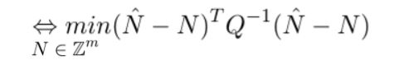

As the region is shrinking, we are searching for size and shape of the search space which lead to following drawbacks are as :

Too Large search space which lead to large computing time and many possible solutions hence no exact solutions.

Too small lead to some solution which are clear and exact might not include in the search space which will be excluded.

Hence we need search space to find the confidence region with which we can estimate the size and shape of the search space. All the ambiguities are float and optimization float of solutions as the all ambiguities are decorrelated. Hence we are validating the float and fixed ambiguities. Introduce integers ambiguities as known observations and re-estimating of the parameters again. We are setting up the ambiguities to fixed value integers so it is not correlated and does not affect the other ambiguity. So fixed ambiguity is better than float as the integers value of the ambiguity is floating not fixed.

After completing all steps, all parameters will be change by fixing the ambiguities and fixed ambiguities parameters have better accuracy and precision as compared to float solutions at the beginning. Hence ambiguity is deterministic. Rounding method can be used to rounding the ambiguity to next integer value. So fixed ambiguity(integers value) is better than float ambiguity solutions. In PPP approach fixing ambiguity can allowed wide ambiguity as it is independent of baseline which lead to better accuracy.

Task 1.2

The change of the estimated coordinates are as :-

delta_x = [mm]

|  |  |
| --- | --- |
| With rounding method new coordinates are as:- | With 2nd Ambiguity transformations we will get new coordinates:- |
| -9.60317460317462 | 3458.57142857143 |
| 29.8412698412698 | -7794.28571428571 |
| 28.5714285714286 | -6742.85714285714 |

New variance covariance matrix are as:-

Q_x_fix =

-108.333333333333 719.047619047619 500

719.047619047619 -1194.04761904762 -1228.57142857143 [mm^2]

500 -1228.57142857143 -824.999999999999

Here we are using the float ambiguities to calculate and variance covariance matrix with rounding method which we are rounding the integers to nearest value to evaluate it and follow the single value of decomposition which gives the Eigen value and Eigen vectors. Following up the transformation of the ambiguity. As mention it the lecture notes we are rounding up next value for an integers ambiguity and it very easy to use but the approach is not certain.

**Task 1.3**

Functional Search space can be set up by the feasible region which is all the integers entries are possible candidates. Ambiguity is not countable as infinite number which is too large for the search space. N can be obtained as a float solution.

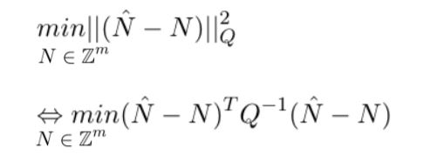

The Confidence matrix influence the shape of the search space and the complexity of the solution algorithm. Size and shape of the search space affect the solutions are as:-

Too Large search space which lead to large computing time and many possible solutions hence no exact solutions.

Too small lead to some solution which are clear and exact might not include in the search space which will be excluded.

Confidence region is necessary for the to find out the search space. The confidence region influence and affect the shape of the search space and the complexity of the solution algorithm.

If the confidence region(Q) is having all the ambiguities are decorrelated then minimum distance which optimize the solutions. If the confidence region for the ambiguities are hyper ellipsoid with all the confident candidates are in the ellipse with discrete optimizations. Search space is the space in which all the possible candidates are fall under the search space. Every candidates are the feasible possible solutions. We need to form different search space like ellipse and rectangle. Ellipse is done by the eigen value one max Eigen value is major axis and smallest Eigen value is minor axis. The theta is obtain from Eigen vector. The correlation between the candidates is done.



The correlation value is 0.9912.

**Task 1.4**

LAMDA Method

Least Squares Ambiguity Decorrelation Adjustment(LAMDA) is the abbreviation for the LAMDA method.

FARA and SIGMA method are used an approach with element wise analysis which increase the search space and time consuming. While in LAMDA method is mainly for the decorrelations and focusing on confidence search space(ellipse) hence it is more robust and effective independent of the all candidates of the search space. Lambda method is not time consuming.

Step1

If the Qnn shows the diagonal matrix then there is no correlations between ellipse axis and the ambiguity as the N1 and N2 are the axis and some inclination ellipse which is independent of the ambiguity. Highly correlated ambiguities are difficult to rounding up in next step.

Step2

Rounding up the nearest integers value for ambiguity. It depends on short time of measurements if the ambiguity is fully populated or not. If the candidates ambiguity is for short time and fully populated then we have to de-parameterization to decorrelation of the candidates ambiguities.

Step 3

Re-parameterization can be done by transforming of the real value ambiguities. The less precise ambiguities are transformed first followed by highly precise ambiguities. The decomposition of the VCM matrix. $Transform less precise {\hat{N}}_{i}→\hat{z}⋅ⅈ$ and then transform other ambiguities ${\hat{N}}_{j}→\hat{z}j$.

Step4

Round more precise transformed ambiguity ${\hat{z}}_{j}→{\tilde{z}}_{j}$. After decomposition we are modifying Q matrix to efficiently calculated from the factor candidates. Change the further ambiguity ${\hat{z}}_{j}→{\tilde{z}}_{i/j}$

Step5

Round up the further ambiguity ${\hat{z}}_{i/j}→{\tilde{z}}_{i/j}$ and Integers will be Gauss transformed and absolute value of the diagonal will be transformed.

Step6

Cross verify the objective functions if the omega is suitable or not. For the single baseline, decorrelation ambiguities transformed are recording of the conditional variances.

Step7

The searchable region is shrinking and the we can obtain the possible region.

$$F^{'}={\left(\hat{z}-z\right)}^{T}Q_{\hat{z}}^{-1}\left(\hat{z}-z\right) ≤χ^{2}Ω$$

We are estimating integers ambiguity by sequential condition of LSA least square estimation process. The bound of the interval as small the interval will be small the conditional variance.

Step8

Search candidates within the sequential or in the ellipsoid will be stored and shrinking the ellipsoidal region. We are estimating the candidates collecting and storing the search candidates.

Step9

We have to done with all possible observation in the feasible region with all pair of candidates.

The volume of the ellipsoid will be control the ambiguity search space which know the number of candidates contained and minimization the problem.

Step 10

Back transformed the ambiguity $\tilde{Z}→\tilde{N}$ as we are Minimization of the problem is done than we are back transforming the integer candidates estimate to obtain from LSA. Hence we will get fixed solutions.

LAMDA method divided into mainly 3 parts Float solution, Integer Ambiguity and fixed solutions. Hence we will get the final fixed ambiguities solutions.

**Task 1.5**

The RTK carrier phase measurements are more accurate than code measurements. If we fix the ambiguity for the phase for PPP then convergence become unambiguous. Hence it is difficult to estimate the integers ambiguities in PPP approach. Ambiguity is estimate with the help of DD(double difference) by using of 2 receiver we can estimate the integers ambiguity. In PPP, we have only 1 receiver which is difficult to modelled the integers ambiguity. Double difference we can eliminate the geometry, ionosphere, multipath error which is cancel out due to dual receiver. We have to model such error in PPP with single receiver. Hence we cannot estimate integers ambiguity in highly precise manner as we can have in DD for 2 receivers.

**Task 2**

**Task 2.1**

Linear combination is most important for the eliminate of the error which are present in the form of geometry, ionosphere in signal. Hence we are using linear combination approach to combine the signal to eliminate the error.

$$L_{x}=k_{i,x}⋅L_{i}+ k_{i,x}⋅L_{j }$$

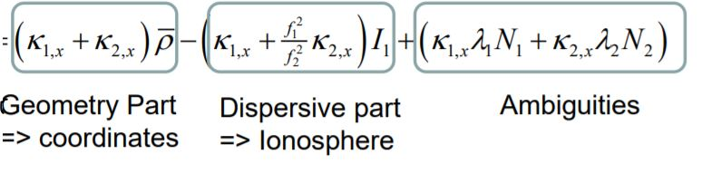

Where, i=1 and j=2

Linear combinations is the combination of the 2 frequency which will reduce the ionosphere and troposphere effect. If we add 3rd frequency than it will reduce the noise and multipath effect. The effect of ionosphere and troposphere is depend on the baseline if the baseline is short then effect will be less or vice versa. We are using such approach to reduce the noise and increase the quality of the signals.

Advantages

1- Systematic effect can reduce or eliminated.

2- Ambiguity solutions will be improved.

Disadvantages

1-The noise factor for the Wide lane increase by factor of 6.

2- For the baseline 10km and more, noise factor increase by factor of 3 in case of Ionosphere linear combinations.

It is 2nd approach for the ionosphereric influences are as:-

$$L_{i}=\overline{ρ}-I_{i}+λ_{i}N_{j}$$

$$L_{j}=\overline{ρ}-{\frac{f_{i}^{2}}{f_{j}^{2}}I}_{j}+λ_{i}N_{j}$$

$$L=K_{i}L_{i}+K_{j}L_{j}$$

$L_{0}=\overline{ρ}- \frac{f_{i}^{2}}{f_{i}^{2}-f_{j}^{2}}λ_{i}N_{j }$- $\frac{f_{j}^{2}}{f_{i}^{2}-f_{j}^{2}}λ_{i}N_{j}$

Where , $\overline{ρ}$ = non dispersive medium, geometrical part

I = Ionosphere refraction

K= geometry factor, k1 + k2 =1

Λ = wavelength

N = Integer Ambiguity

**Task 2.2**

The common 4 linear combination are as:

1- Geometry Free linear combination

2- Wide lane linear combination

3- Narrow land linear combinations and

4- Ionosphere free linear combinations

|  |  |  |  |
| --- | --- | --- | --- |
|  | LC name | Advantage | Typical Approach |
| 1 | Geometry Free Linear Combinations | Remove all frequency depend effects which are instruments delay, phase wind up, multipath and measurements noise | It is used for the finding electron content in ionosphere, rotations of the antenna and detect the cyclic slips. |
| 2 | Wide lane linear combination | Create the signal with wide land wavelength. It is useful to detecting the cyclic slip and fixing the ambiguity. | Used in Melbourne Wübbena Combination(removes the ionosphere refraction) to change the sign of ionosphere term. |
| 3 | Narrow land linear combinations | It has lower noise and create the signal with narrow wavelength. | The code noise can be reduce in Melbourne Wübbena Combination which his used to estimate the wide land ambiguity. |
| 4 | Ionosphere free linear combinations | Removing the first order of ionosphere effects(refraction/delay). | PPP used code & carrier phase measurements to remove ionosphere effect. |

**Task 2.3**

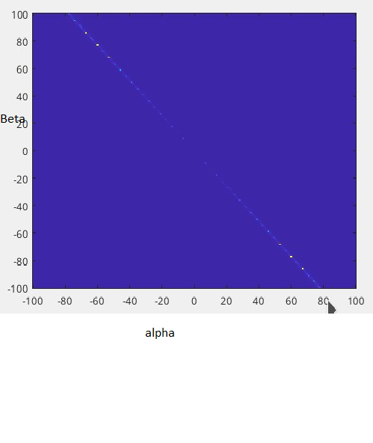

Figure 1 Ionosphere effect

Ionosphere $I_{αβ}=-\frac{αβf_{1}f_{2}+βf_{1}^{2}}{f_{2}\left(αf_{1}+βf_{2}\right)}*I_{1}$

Wavelength $λ_{αβ}=\frac{c}{\left(αf_{1}+βf_{2}\right)}$ and

Ambiguity $N_{αB}=αN_{1}+βN_{2}$

Where , α and β are the coefficient

f is the frequency

c = speed of light

**Task 2.4**

Eigen vector is orthogonal is orthogonal to each other and define the by some angle theta. The Q matrix is need to be transformed so it should be integers value after transforming which should not lose the integer nature. This approach hinder the transform matrix to fulfill the conditions mention below.

Ambiguity is transformed :-

$\left[\begin{aligned}N_{α} \\ N_{B}\end{aligned}\right]$ = $\left[\begin{matrix}α & β \\ Y & δ\end{matrix}\right]$ $\left[\begin{aligned}N_{1} \\ N_{2}\end{aligned}\right]$

Where T = and N1 & N2 is integers

Transformation conditions is to be invertible and satisfy $αδ-yβ≠0$, hence alpha, beta and gamy and delta is an integers.

The determinant of T matrix =1 so we can save it. As we can have learn from lecture for narrow and wide lane ambiguity have transformation matrix is

T = $\left[\begin{matrix}1 & 1 \\ 1 & -1\end{matrix}\right]$, so the determinant is -2 which is disobey the rule. And all the value of the inverse matrix should be in integers is not fulfilled T = $\left[\begin{matrix}0.5 & 0.5 \\ 0.5 & -0.5\end{matrix}\right]$.

Conditions for the transformation matrix are as:-

1-det T $≠$ 0. $αδ-yβ≠0$.

2- αβγ and δ belongs to integers value.

3- Inverse of the T matrix is also be integers.

Hence the Eigen value decomposition is not valid for the ambiguity transformations.

**Task 3**

**Task 3.1**

The capability of the navigation system to time to alert the user if the position error is exceed then the alert limit or threshold set by on the position error. It is mainly used to alert the user in specified time to avoid the incident. There are many other definition too. It is used to perform the operations like landing, takeoff and enroute.

The quality of the Integrity is measured on the parameters are as :-

1- Precision , Accuracy

2- Integrity

Integrity Risk, Alarm Limit, Time to alert

3- Continuity

4- Availability

1- Precision

Precision is the quality of the measure for the agreement of the estimated position and the actual/true position defined for the particular task by the defined user. It is quantify as the position error with respect to the define positions. Hence how much the position is precise with respect to the true positions.

2- Integrity

Integrity is the ability of the system to provide timely warnings to the user when the equipment is unreliable for navigation purposes. The concept of integrity includes a failure to alarm and a false alarm. [caa-civil aviation authority]

a) Integrity Risk

Integrity Risk – Probability that the during the operations all the signal receive by the aircraft shows some positions error which lead to misleading the direction of approach mainly landing approach hence such approach is fly by the user visually and system warn or alert the pilot in time to avoid the incidents if the path was misled by an aircraft in mention threshold. Such type of risk fall under integrity risk. It may include Vertical(enroute), horizontal position errors(taxing the aircraft).

b)Alarm Limit

There is also norms publish by the ICAO for specified the approach, flight, etc When the aircraft fly beyond the threshold limit then to warn the pilot for avoiding the collisions, Such threshold value is called alarm limit. Hence there is no practically any alert limit specified it vary as per approach , aircraft, aerodrome but as per the lecture notes it is set under certain limits. The position error can smoothly perform any operation are called under the alert limit.

C) Time to alert

In the mention time, time to alert the positions error for example in aircraft especially for take-off and landing to perform the perfect the approach or operations for safety of the aircraft and avoid any incidents are called time to alert. For landing approach or takeoff approach there is no specifically mention like time to alert but it depends on the speed of the aircraft, length of the runway and Touch down zone different factors. Hence for general purpose we need time to alert to avoid any incidents in mean available time for the safeguard.

3- Continuity

The continuity means the capability of an aircraft navigations system to complete an operations without any alarm with predefined accuracy/precision in mention integrity limit during the period of the operations.

4- Availability

It can describe as percentage of the time during that a navigation system provides the specified functionality for example accuracy, integrity and continuity must be fulfilled. The availability of the signal or guidance in the dense weather to perform the aircraft approaches properly which may include integrity.

**Task 3.2**



Figure 2 VPL & VPE vs time



Figure 3 Stanford Diagram

Case 1 System Unavailable

When vertical protection level(VPL) is higher than vertical alert limit(VAL) than system is unavailable.

Case 2 Normal Operation

When Vertical protection error(VPE) is less than vertical alert limit(VAL) and Vertical protection error(VPE) is less than vertical protection level(VPL) than normal operations are to be conducted.

Case 3 Misleading Information

When Vertical protection error(VPE) is higher than vertical protection level(VPL) and Vertical protection error(VPE) is less than vertical alert limit(VAL) than misleading information occur.

Case 4 Highly Misleading Information

Vertical protection error(VPE) is higher than vertical alert limit(VAL) than Highly Misleading information occur(HMI).

Total amount of percentage with amount of the observation fall are as:-

|  |  |
| --- | --- |
| **Cases** | **VAL = 7 meter , Amount/%** |
| System Unavailable | 168 observation / 33.6% |
| Normal Operation | 189 observations / 37.8% |
| Misleading Information | 122 Observations / 24% |
| Highly Misleading Information | 21 observations / 0.04% |

|  |  |
| --- | --- |
| System Unavailable | Any operation cannot be conducted |
| Normal Operation | All operation can be conducted |
| Misleading Information | If the alternative guidance is available then with reference to alternative approach we can perform operation. We cannot perform any operations. |
| Highly Misleading Information | Do not perform any operation , Change the another guidance system to navigate the aircraft to runway to perform safe approaches. |

Mainly approaches are divided into 3 parts which are perform on the base of instruments are as :-

Take-off

Enroute and

Landing. Like taxing and other approaches are done visually by the pilot hence it fall under VFR visual flight rule while all with instruments are fall under IFR (Instruments flight rule).

**Task 3.3**

Interval Mathematics

Alternative approach for the integrity is to set the interval for the observations by deterministic error bands. For example setting up the lower bound and upper bound from which we can calculate the mean point.

am =1/2 (al+au)

where , al = lower bound

au = upper bound

am = mean bound

ar = radius

There are many other approaches are available for the measuring the integrity are used by Airbus is RAIM(Receiver autonomous integrity monitoring) based on the satellite observations. In lecture there is short discussion of RIMS(Receiver integrity monitoring system) which is another version of the RAIM. Currently paper publish, so by setting up the mathematical interval based and other is stochastic integrity approaches.(not mention in details in lecture)

**Task 3.4**

Normal distribution correspond to the 2D error for a GNSS based positioning. The distance error is shown vs count/bins. The fig6 is the Euclidian distance plot to analyses the positions error.



Figure 4 dx vs count



Figure 5dy vs count



Figure 6dxy vs count

Reference

1- Lecture notes Prof Schön

2- Navipedia

3- Publications : [GRK 2159: Integrität und Kollaboration in dynamischen Sensornetzen (i.c.sens)](https://www.icsens.uni-hannover.de/de/)

4- Lab notes from Semester 18/19